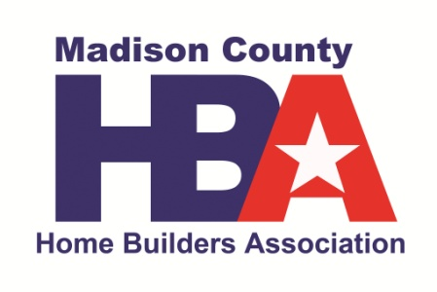

February 8: Board of Directors Oath of Office & Elections Member Meeting
Location: MCHBA Office

February 26, February 27: 2018 Kentucky Residential Code Significant Changes Seminars Member Education
Location: Lexington

March 7: HBAK Legislative Update & Awards Member Meeting
Location: MCHBA Office

March 27: CPR & Blood Borne Pathogens Member Education
Location: Baptist Health

April 24: 22nd Annual Golf Scramble Member Event
Location: Battlefield Golf Course

May 11: Car Show Member Event
Location: Richmond Mall

June TBD: Optimizing Google Search Member Meeting
Location: MCHBA Office

August 4: Touch –A-Truck Member Event
Location: EKU Stadium Parking Lot

August TBD: Mold Screening Class Member Meeting
Location: MCHBA Office

September TBD: HR/ Drug Screening Class Member Meeting
Location: MCHBA Office

October TBD: Safety and Codes Member Education
Location: MCHBA Office

November TBD: Unemployment Law Class Member Education
Location: MCHBA Office

December 31: New Years Eve Party Member Event

For Additional Information, please contact Suzi Van Etten
859-624-0830 or madisoncohba@bellsouth.net

